2017 SIL/AUC DATABASE

DOCUMENTATION - USER GUIDE

Pacific Biological Station
Stock Assessment Division
3190 Hammond Bay Road
Nanaimo, BC
V9T 5K6

Table of Contents
1.0 BACKGROUND 1
1.1 Technical Support: 1
2.0 THE APPLICATION 1
2.1 Hardware Required 1
2.2 Installation Procedure 1
2.3 Starting The Application-Initial Setup 2
3.0 TOUR OF THE APPLICATION 3
3.1 Set-up tab 3
3.2 Link Backend Database 3
3.3 Update NuSEDS Lookup Values 5
3.4 Set-Up-Utilities 7
4.0 ENTERING SIL INFORMATION 7
5.0 ENTERING SEN INFORMATION 17
5.1 Main Screen 17
5.2 AUC & PL+D Calculator 17
5.3 Peak Live+Dead Calculator 22
5.4 Set Recommended 23
6.0 OTHER FEATURES 26
6.1 Error Check 26
6.2 Report 27
6.3 Importing Data 28
6.4 Exporting Data 28
APPENDIX A- GROUND LEVEL SIL FIELD DEFINITIONS 30
APPENDIX B- AERIAL SIL FIELD DEFINITIONS 39
APPENDIX C- SEN FIELD DEFINITIONS 40
APPENDIX D- ESTIMATE CLASSIFICATIONS DEFINITIONS 48

1.0 BACKGROUND

The SIL/AUC Database system was developed as a Regional standalone MS Access application that would allow DFO staff and external users the ability to enter SIL (Stream Inspection Log) data into an MS Access Database. Over time the application has evolved to include an AUC calculator and the ability to produce annual escapement estimates or SENS (Summary Estimate Narratives). The SIL/AUC database system consists of a front end and a back end access database which are distributed to DFO and non DFO groups before the beginning of the field season. SIL data are entered into the database at the end of the field season and the back end databases are retrieved by DFO personnel for analysis and upload into the NuSEDS Database.

1.1 Technical Support:

If you have any questions or need assistance please contact Bruce Baxter


(250) 756-7063 bruce.baxter@dfo-mpo.gc.ca

2.0 THE APPLICATION

2.1 Hardware Required

The suggested hardware required to run this application is a Pentium computer running Microsoft Access.

2.2 Installation Procedure

This manual assumes that MS Access is already installed on your machine’s hard drive.
The First step is to copy the front end and back end databases to a directory on your computer’s hard drive or network drive. The following two databases will have to be copied:

SIL+AUC Codebase v10.1.mdb-This is the application

SIL+AUC Database v9.1.mdb-This is the back end database where the actual data are stored. It is recommended that this database be renamed to reflect the Year and Area you are working in eg: SIL+AUC Database v9.1 2012_GST.mdb

2.3 Starting The Application-Initial Setup

Step 1. Start the application by double clicking on SIL+AUC Codebase v10.1.mdb.

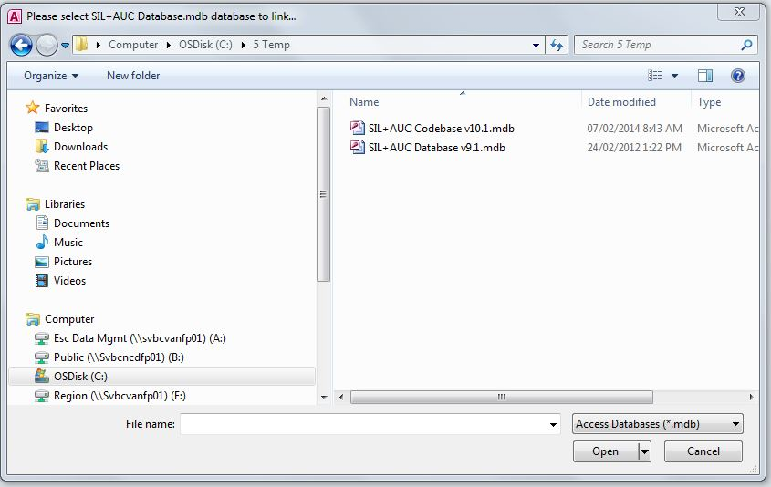
Step 1

Step 2. A message will appear to link the back end database-Click OK

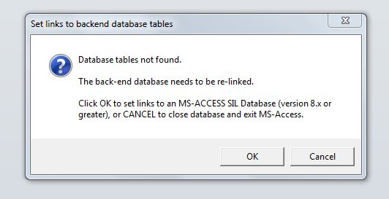
Step 2

Step 3. A message will appear to select SIL+AUC Databse.mdb database to link. Find the directory on your hard drive or network drive that you have stored the database and double click on the Database. Tables will be linked and the following message will appear-Click OK

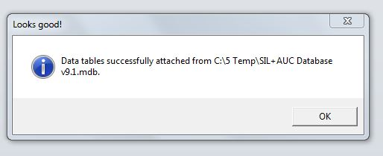
Step 3

3.0 TOUR OF THE APPLICATION

3.1 Set-up tab

3.2 Link Backend Database

This is the initial set-up screen that needs to be completed before data entry can occur.

Step 1. Click on “Link Backend Database Tab”.

Step 2. Click on “Identify Current Backend Database”. A screen will appear showing which back –end database the program is currently attached to. Follow the instructions on this screen and accept the back-end database by pressing “OK” if this is the back-end database you would like to use

Step 3. Click on “Set Links to Access Database”, if you would like to attach the program to a different back-end database.
.

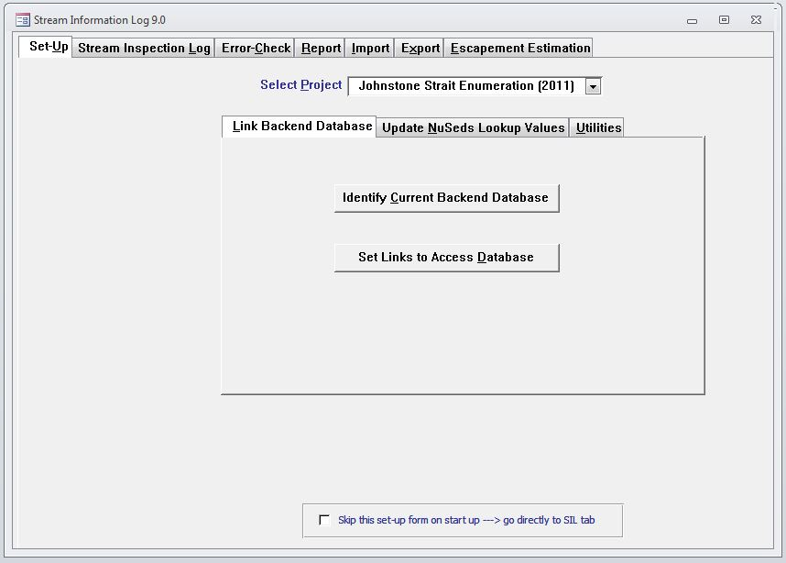
Step 1
Step 2
Step 3

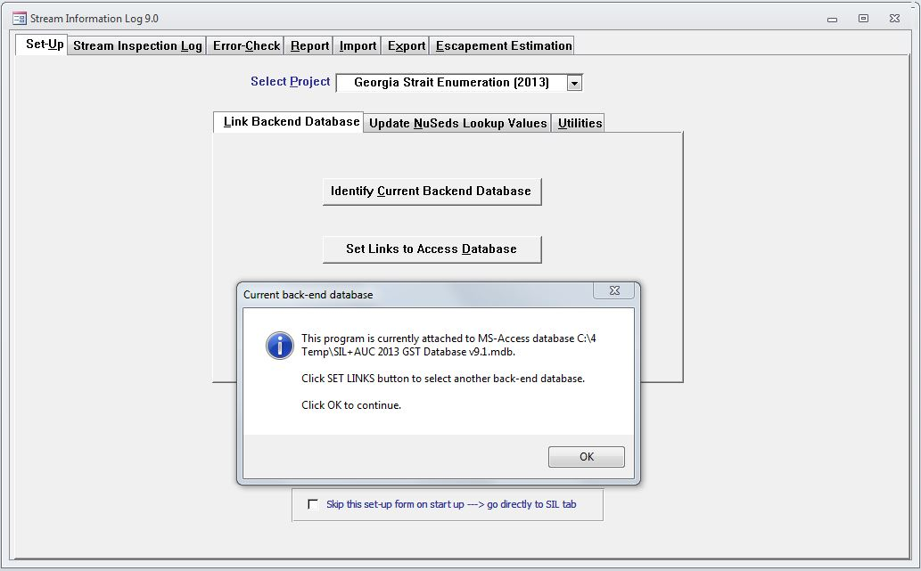

3.3 Update NuSEDS Lookup Values

This Tab allows the user to update project values, Waterbody Values, Segment Values, Affiliation Values and Participant Values from an excel workbook. The user can choose all or some of the values to update.

Step 1. Click on the “Get New Lookup Values”. A screen will appear showing the directory of your computer.

Step 2. Find the directory that contains the SC_SIL_Import2.xls file and double click on it.

Step 3. A screen will appear that shows that the values have been updated click on “OK” to accept which will take you back to the main screen.

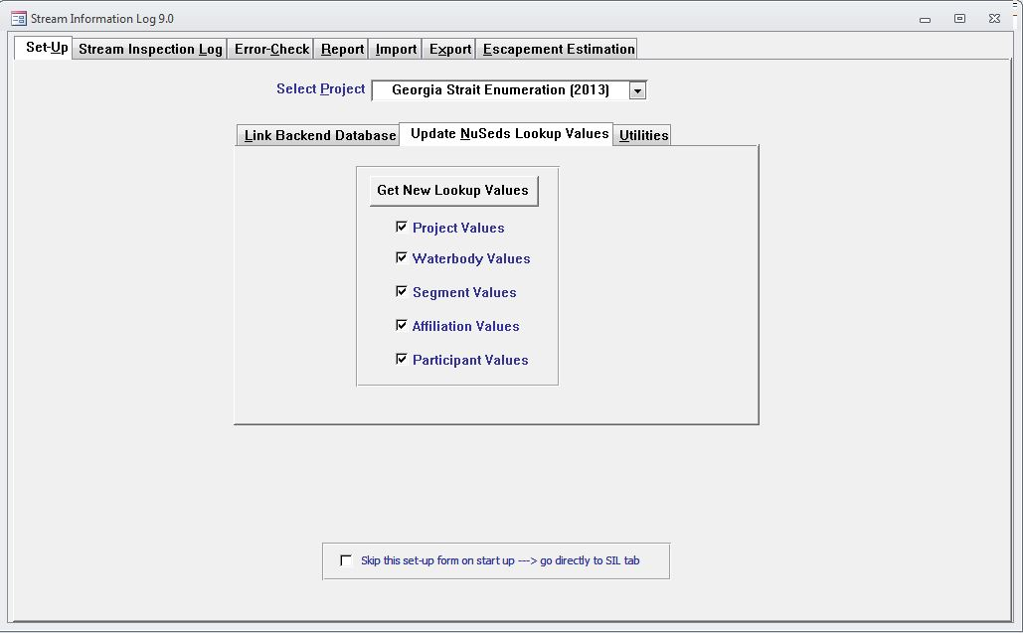
Step 1

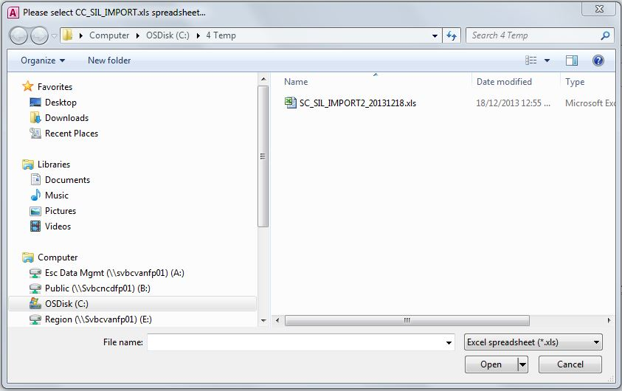
Step 2

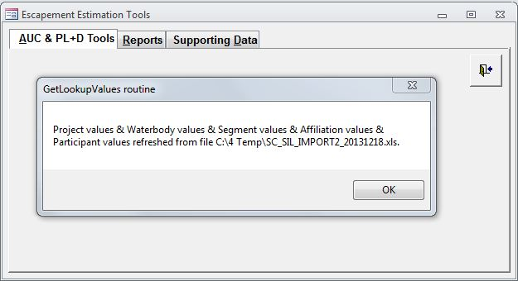
Step 3

3.4 Set-Up-Utilities

This Tab allows the user to set Compact on or off for the access database, controlling the size of the database.

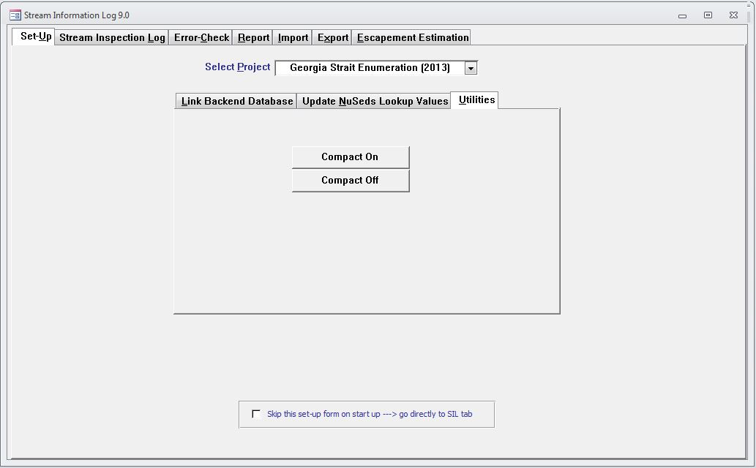

4.0 ENTERING SIL INFORMATION

The data is automatically saved as it is entered which means that you may enter data for more than one Stat Area or Stream or Date without exiting the data entry function. Simply change stream information fields (Stat Area, Stream, Year and Date) as required and proceed with completing the remainder of the form. There is a delete button in the Inspection Details and Segments Tab if you wish to delete a survey.

Step 1. Select appropriate project from drop down list
Step 2. Select Stream Inspection Log Tab
Step 3. Select Area drop down box and choose appropriate Area you are entering SILs for.
Step 4. Select Stream drop down box and choose Stream you are entering SILs for.
Step 5. Select Year drop down box and choose Year you are entering SILs for.
Step 6. Select Month drop down box and choose Month you are entering SILs for (1-12).
Step 7. Select Day drop down box and manually enter Day you are entering SILs for (1-31)

Step 1
Step 2

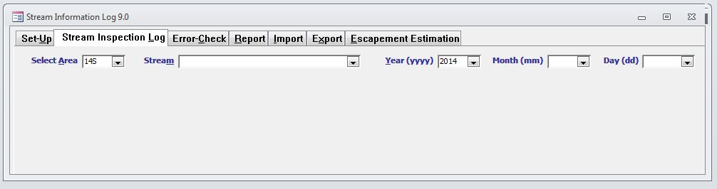
Step 3
Step 4
Step 5
Step 6
Step 7

Once finished these steps press enter. The following screen will appear. If you would like to create a SIL click on Yes.

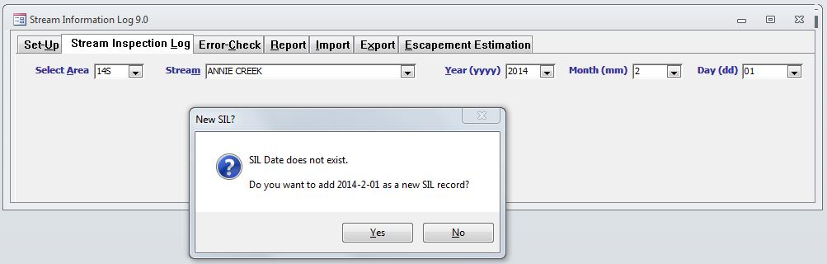

The following data entry screen will appear

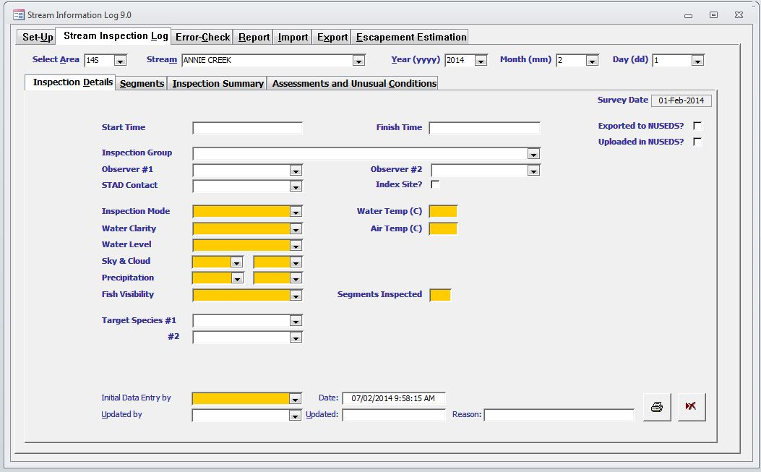
Delete Button
Note: Orange Highlighted Cells are Mandatory

Begin by filling in the inspection Details as completely as possible. Note: orange highlighted fields are mandatory and must be filled in. Please refer to Table 1 for a description of the SIL inspection details fields. If for some reason you would like to delete this survey click on the delete button at the bottom right hand corner of the form.

TABLE 1. SIL-INSPECTION DETAILS DEFINITIONS
Field Name | Definition
START TIME | This is the time (military time) that the stream inspection began, eg: 08:00.
FINISH TIME | This is the time (military time) that the stream inspection ended, eg: 14:00.
EXPORTED TO NUSEDS
UPDATED IN NUSEDS
INSPECTION GROUP | Choose the group that conducted the stream inspection from the drop down list.
OBSERVER #1 | Choose the primary observer that conducted the stream inspection from the drop down list.
OBSERVER #2 | Choose the second observer that conducted the stream inspection from the drop down list.
STAD CONTACT | Choose the STAD contact for the stream inspection from the drop down list.
INDEX SITE | Check this box
INSPECTION MODE | Mandatory field that must be filled in (Highlighted Orange). If Aerial chosen aircraft type box will appear.
AIRCRAFT TYPE | Mandatory field that must be filled in (Highlighted Orange). Choose from drop down box.
WATER CLARITY | Mandatory field that must be filled in (Highlighted Orange).This is an indication of how visible the fish are. It should be estimated at a location where you cannot see the bottom. This could be based on Secchi disc reading or a visual estimation in the deepest water. If the bottom is visible throughout the area surveyed then choose 3m-5m or to bottom. For snorkel inspections water clarity should be estimated horizontally at a location where you cannot see the opposite bank.
WATER LEVEL | Mandatory field that must be filled in (Highlighted Orange). This is a subjective assessment of water depth chosen from the drop down list.
SKY & CLOUD | Mandatory field that must be filled in (Highlighted Orange). The percentage of visible sky that is filled by clouds chosen from the drop down boxes.
PRECIPITATION | Mandatory field that must be filled in (Highlighted Orange). This is an average indication of rain and/or snow conditions during the inspection that will influence fish visibility. Choose appropriate values from the drop down boxes.
FISH VISIBILITY | Mandatory field that must be filled in (Highlighted Orange). This is a classification of the average visibility of the fish as influenced by water properties, sky conditions and precipitation during the inspection. If there is a significant long lasting change in environmental conditions affecting stream visibility during the inspection then another SIL should be filled out. Choose from drop down list.
SEGMENTS INSPECTED | Mandatory field that must be filled in (Highlighted Orange). This is the number of segments that were inspected during this stream survey.
TARGET SPECIES #1 | This is the primary salmon species that was targeted during this stream inspection-note that survey timing will need to coincide with this salmons presence. Choose species from drop down list.
TARGET SPECIES #2 | This is the secondary salmon species that was targeted during this stream inspection-note that survey timing will need to coincide with this salmons presence. Choose species from drop down list.
INITIAL DATA ENTRY BY | Mandatory field that must be filled in (Highlighted Orange). This is the person who is responsible for the initial data entry into the Database. Choose from drop down list.
DATE | This field is filled in automatically.
UPDATED BY | This is the person who is responsible for updating the SIL in the database. Choose from drop down list.
UPDATED | Use pop-up calendar to add in the date that the SIL was updated.
REASON | Add in a reason why the SIL was updated.
Note: Grey highlighted fields are calculated automatically and Orange highlighted fields are mandatory and need to be filled in.

Once all of the inspection details are filled in click on the Segments tab and choose the segment for which the inspection is for. A message will appear to create a new record-click yes to create a new record

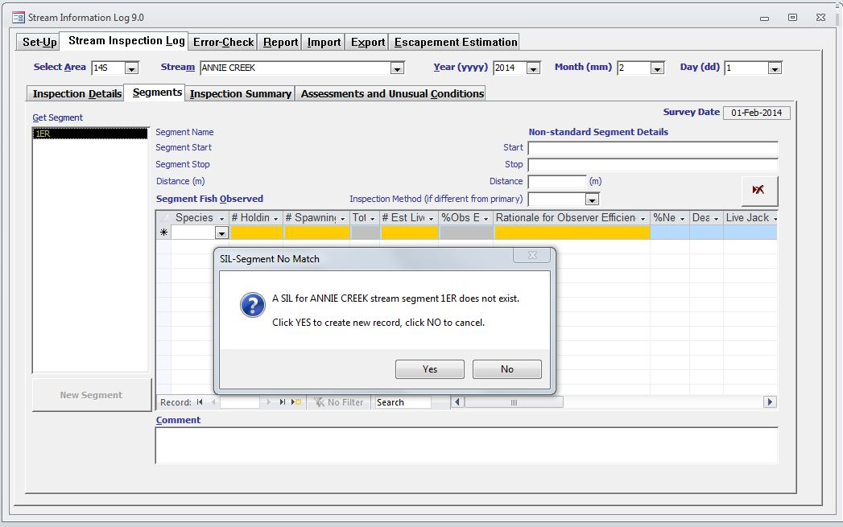

Fill in the Segment Fish Observed Section-Note: orange highlighted fields are mandatory and must be filled in. Grey cells are calculated fields and will populate automatically once the yellow highlighted information is filled in. Complete information for all species observed.

Non-Standard Segment Details-This section is used if the start and stop boundaries are different than the start and stop boundaries for the standard segment.

Please refer to Table 2 for a description of the SIL segment details fields. If for some reason you need to delete this stream survey click on the delete button on the form.

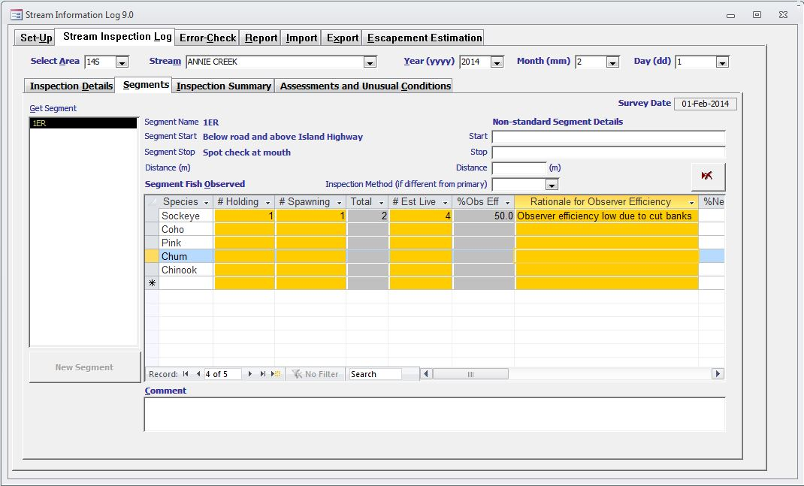
Delete Button

TABLE 2. SIL-SEGMENT DETAILS DEFINITIONS
Field Name | Definition
STANDARD SEGMENT DETAILS
GET SEGMENT | Choose stream segment from the drop down list.
SPECIES | This is one of the five species of salmon being estimated.
# HOLDING | Mandatory field that must be filled in (Highlighted Orange). This is the number of fish observed that are not paired nor actively spawning. This number may be zero if there are no fish present or if all fish are spawning and/or dead.
# SPAWNING | Mandatory field that must be filled in (Highlighted Orange). This is the number of fish observed that are paired and/or actively spawning.
TOTAL | This is a calculated field (highlighted Grey). This is the calculated sum of # holding and # spawning fish.
# EST LIVE | Mandatory field that must be filled in (Highlighted Orange).This is an estimation of the number of live fish thought to be in the segment and includes the observed count plus the number of live fish that the observer feels were in the segment, but were not observed. Unseen fish could be in areas such as: under cutbanks, log jams, deep water or side channels.
% OBS EFF | This is a calculated field (highlighted Grey) and is based on number of fish observed and estimated.
RATIONALE FOR OBSERVER EFFICIENCY | Mandatory field that must be filled in (Highlighted Orange). Provide an explanation for the observer efficiency which could include stream visibility, undercut banks, etc.
% NEW | This is an estimate of the percentage of fish that have recently arrived to the stream, ranging from 0% to 100%. This can be based on numeric differences between inspections or on the physical condition of the fish in this inspection. New fish are usually bright fish with no fungus or white-coloured, eroded fins.
DEAD | Number of dead adult fish observed in the segment. Dead fish include all carcasses that can be identified to species and are reasonably complete (e.g. not just a fragment of spine).
LIVE JACKS | This is the number of live jacks observed.
OTHER | Record the type and number of other subjects (4 bears, 12 eagles, 3 anglers, etc.). Avoid using qualitative terms like "few" or "a lot".
NON-SALMONID SPECIES COMMENTS | Add comments for non salmonid species.
COMMENT | Add in any comments specific to the stream segment inspection.
NON-STANDARD SEGMENT DETAILS
START | This is a description of where a non-standard segment starts. It can either be a permanent landmark or be described by coordinates.
STOP | This is a description of where a non-standard segment stops. It can either be a permanent landmark or be described by coordinates.
DISTANCE | This is the distance in metres that was surveyed.
INSPECTION METHOD (IF DIFFERENT FROM PRIMARY) | If a different inspection mode is used during this non-standard stream inspection choose the method from the drop down box.
CANOPY | If Aerial is chosen as the inspection mode in the inspection details tab a box will appear for canopy. Choose value from drop down list.
Note: Grey highlighted fields are calculated automatically and Orange highlighted fields are mandatory and need to be filled in.

Once you have completed the segment summary you click on the Inspection Summary tab.
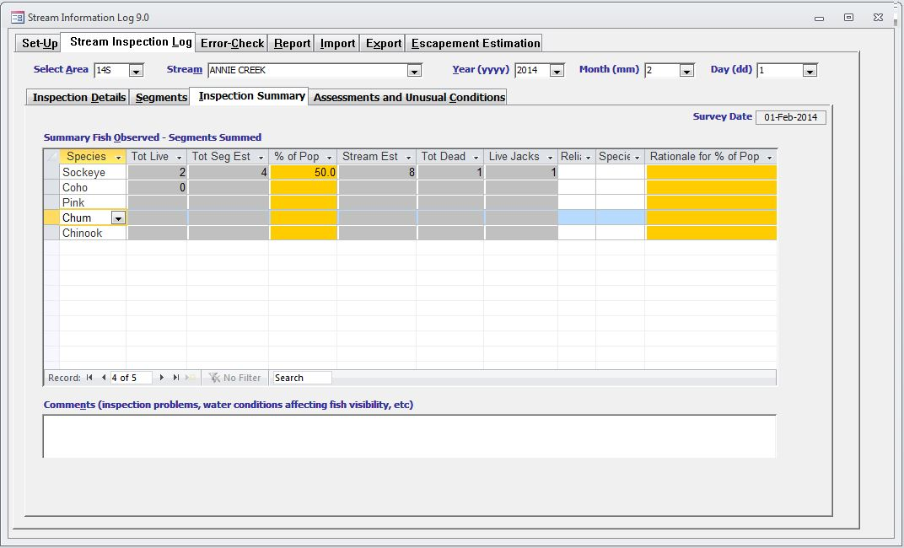

Fill in the orange highlighted cells with the required information for all species and the grey cells will be populated automatically. Please refer to Table 3 for a description of the SIL inspection summary fields.

TABLE 3. SIL-INSPECTION SUMMARY DEFINITIONS
Field Name | Definition
SPECIES | This is one of the five species of salmon being estimated.
TOT LIVE | This is a calculated field (highlighted Grey). It is the total number of live adults of each species actually observed during this inspection and is calculated by summing all segment live Observed.
TOT SEG EST | This is a calculated field (highlighted Grey). It is the total number of live adults of each species estimated to be present during this inspection and is calculated by summing all segment live Estimated.
% OF POP | Mandatory field that must be filled in (Highlighted Orange). This is the proportion of the in-stream adult population for this inspection that was accounted for in the SEGMENT section. This is not necessarily the same as the percentage of the stream that was inspected. Therefore, for a defensible value, you must know the spawning and holding distribution of each species. For example, the sum of all segment combined totals may represent 80% of the total in-stream population at the time of inspection. Record 80% in this field. If all current spawning and holding areas have been inspected then the percent population is 100%.
STREAM EST | This is a calculated field (highlighted Grey). This is the total number of live adults of each species estimated for this inspection calculated by summing all SEGMENT section live Estimated recorded values and applying any expansion resulting from %Population. For example, if five stream segments are inspected and the sum of Estimated for a species from all five SEGMENT section is 10,000, and the %population is 80% then the Stream Estimate is 12,500.
TOT DEAD | This is a calculated field (highlighted Grey). This is the total number of dead adults of each species actually observed during this inspection and is calculated by summing all SEGMENT section dead Observed.
LIVE JACKS | This is a calculated field (highlighted Grey). This is the total number of live jacks of each species actually observed during this inspection and is calculated by summing all SEGMENT section live jacks Observed.
RELIABILITY | This is the observer's opinion of the overall reliability of the estimate for this inspection. It should be based on environmental conditions and possibly %Population. For example, if Stream Visibility was high and the majority of the population was observed then Reliability should be high. If the above was true, but there was difficulty in distinguishing the species then the reliability should be lower.
SPECIES COMMENTS | Add in any species specific comments for the stream inspection.
RATIONALE FOR % OF POP | Mandatory field that must be filled in (Highlighted Orange). If %Population is less than 100% then explain which portions of the stream were not inspected and why. In some cases, in-stream summary estimates are for segment sets describing less than the total habitat available to the species (e.g. streams where estimates are traditional spawner abundance indices and do not describe the total escapement to the stream). Make sure to explain in Explain %Population or (if more room is required) the Comments section, exactly which portions of the stream are/are not included.
COMMENTS | Add in any specific comments for the stream inspection. Comments could include: inspection problems, water conditions affecting fish visibility or any other comments you feel are important to back up your stream estimate.
Note: Grey highlighted fields are calculated automatically and Orange highlighted fields are mandatory and need to be filled in.

Once you have completed entering all of the information click on the Assessments and Unusual Conditions tab and fill in any applicable fields. Please refer to Table 4 for a description of the SIL assessment and unusual conditions fields.

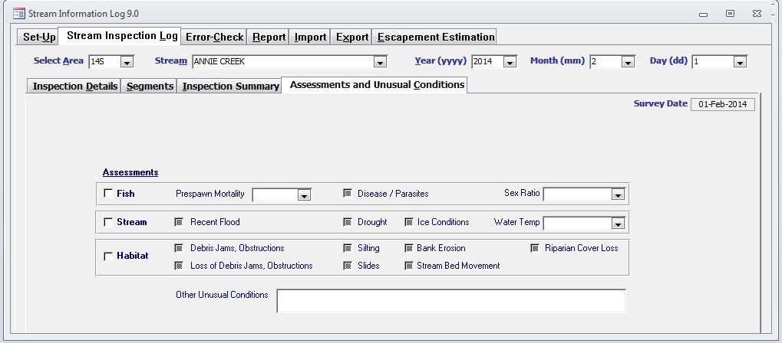

TABLE 4. SIL-ASSESSMENT AND UNUSUAL CONDITIONS DEFINITIONS
Field Name | Definition
FISH-PRESPAWN MORTALITY | This is used to record unusually high or unusually low numbers of adult fish that died prior to spawning. Prespawn mortality is indicated by intact gonads which are best detected by incision.
FISH-DISEASE/PARASITES | This is an indication of unusual presence or absence of fish diseases or parasites.
FISH-SEX RATIO | This is an indication of an unusually high proportion of males or females. Visual determination may be difficult. Carcasses may be used to determine abnormal sex ratios. Sex ratios of live fish may be determined provided there is a clear distinction between males and females using size, shape and/or colour.
STREAM-RECENT FLOOD | This indicates that a flood of unusually high magnitude has recently occurred. An unusual flood produces changes to the channel or enough bedload movement to significantly scour redds and eggs.
STREAM-DROUGHT | This is an indication of conditions dry enough to impede normal fish migration/spawning or to result in the desiccation of redds and eggs.
STREAM-ICE CONDITIONS | This is an indication of freezing conditions that could result in a significant loss of eggs. These conditions would occur when ice has formed in the gravel and is impeding water flow.
STREAM-WATER TEMP | This is an indication of water temperature well above or below the seasonal norm. For example, in the winter this may be a 2 degree Celsius difference, while in summer this may be a 5 degree difference.
HABITAT-DEBRIS JAMS. OBSTRUCTIONS | This is an indication of the appearance of unusual debris that results in jams or obstructions appearing since the last inspection.
HABITAT-SILTING | This is an indication of an unusual deposition of fine particles sufficient to smother eggs.
HABITAT-BANK EROSION | This is an indication of unusual new stream side degradation.
HABITAT-RIPARIAN COVER LOSS | This is an indication of unusual of the loss of stream side vegetation.
HABITAT-LOSS OF DEBRIS JAMS, OBSTRUCTIONS | This is an indication of the loss of debris that results in the elimination of jams or obstructions since the last inspection.
HABITAT-SLIDES | This is an indication of an unusual slope failure resulting in the deposition of large amounts of materials into the stream.
HABITAT-STREAM BED MOVEMENTS | This is an indication of unusual bed load movement that results in sediment loss or deposition. This may include the relocation of stream channels.
OTHER UNUSUAL CONDITIONS | This is an indication of some other unusual condition not captured above.

This completes the data entry portion for this particular stream segment. If other stream segments have been surveyed for this stream during this particular date repeat the process starting at the Segments tab.

5.0 ENTERING SEN INFORMATION

5.1 Main Screen

The SIL/AUC application allows the user to create Area under the Curve (AUC), Peak Live and Dead (PL&D) and custom escapement estimates based on SIL information stored in the database. Click on the Escapement Estimation Tab to begin. The most efficient way to create a SEN is by clicking on the year which will display all of the SILs that are present for this year within the database.

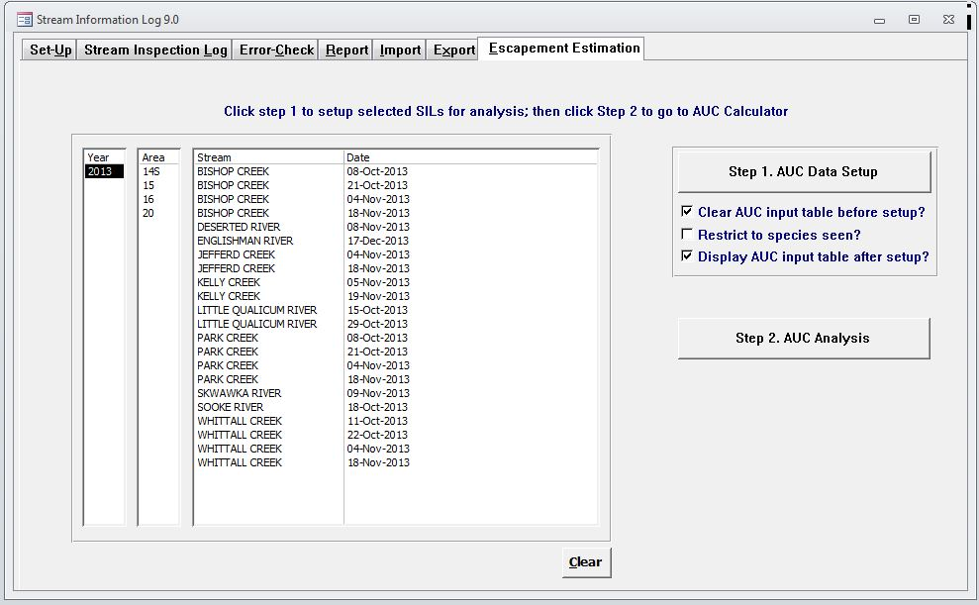

5.2 AUC & PL+D Calculator

Click on Step 1. AUC Data Setup. A screen will appear showing all of the SILs that are in the database. Click OK and minimize the AUC_DataAnalysisTableVIEW.

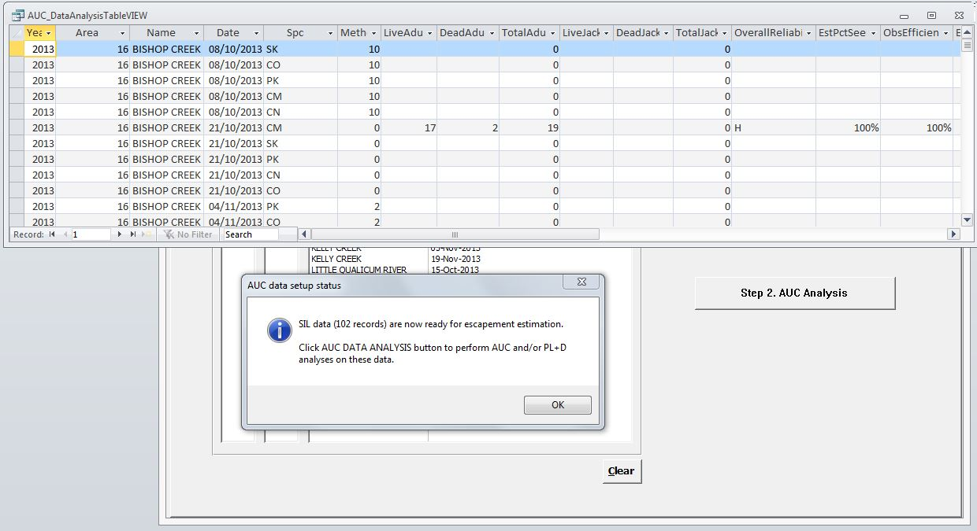

Click on Step 2. AUC Analysis. A screen will appear showing the Escapement Estimation Tools. Choose AUC & PL+D Tools Tab and click calculator. A screen will appear showing the AUC and PL+D Calculator

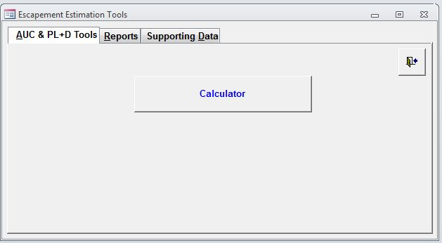

Step 1. Select system you would like to do analysis on from drop down list.
Step 2. Select Year from drop down list.
Step 3. Select species you would like to do analysis on from drop down list.

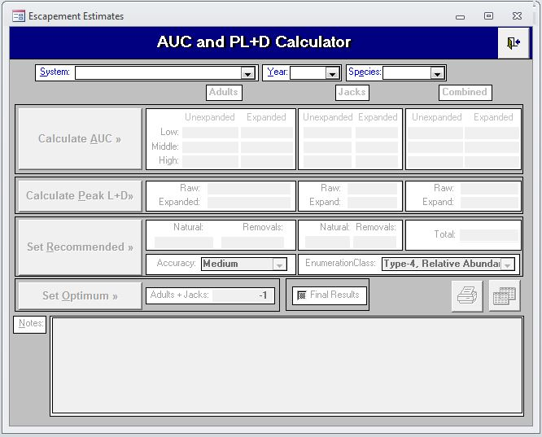
Step 1
Step 2
Step 3

A screen will appear if there is no matching record found. Click on Yes if you would like to create this record.

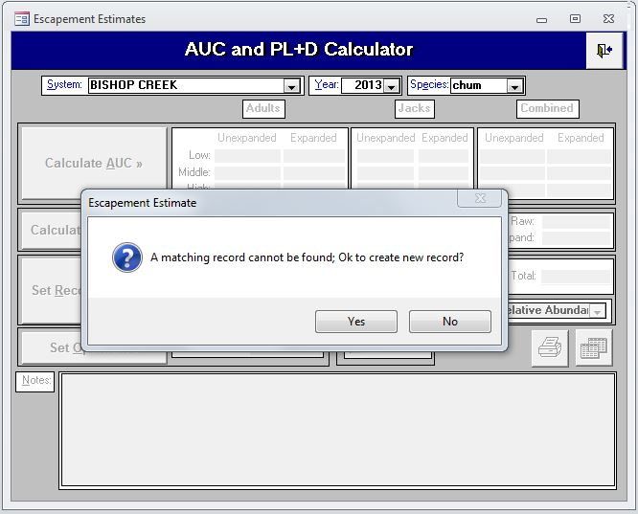

A screen will appear where you can choose the analysis method. Step 1. Click on Calculate AUC button.
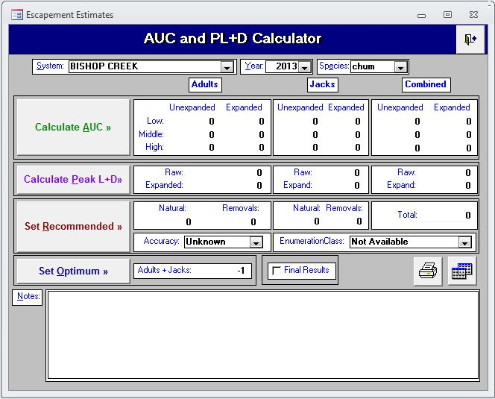
Step 1

A screen will appear showing the SILs that are present for this stream. This allows the user to make a decision whether an AUC analysis is appropriate depending on number of surveys, quality, etc. In this screen you are able to edit expansion factors such as % pop and observer efficiency. You may want to modify the % pop or observer efficiency from the original values in the SIL(s) if you disagree with these values. If you want to change the % pop and it is less than 100% you need to put the value in as a decimal (eg: 80% = .80). Make notes to defend why you may have changed any parameters.

Step 2. Choose Start and End Dates that are before and after survey dates that have fish presence. If you have start or end surveys that have 0 counts you can also use these.
Step 3. Choose Residence Time based on system specific information, Expert opinion or published Literature (eg: Perrin and Irvine Tech Report 1733).
Step 4. If some of the surveys are not needed in the analysis or not valid they can be deleted by highlighting the record and pressing delete.
You can back out of this deletion and return to the original data set by pressing the Reset to Default Data button.

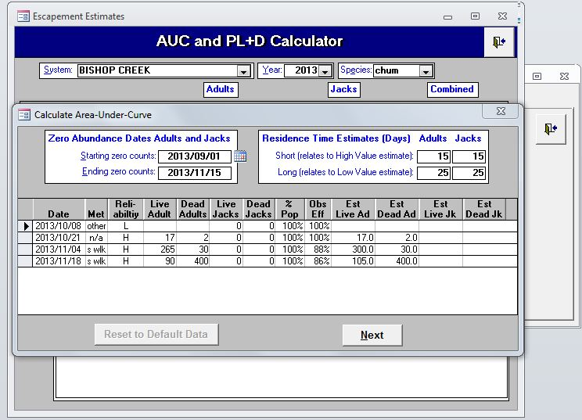
Step 2
Step 3
Step 4

Once these steps have been completed you can press next. The following screen will appear showing the Area-Under-Curve Results. Review these numbers and see if you agree with them. This allows a final review of the results

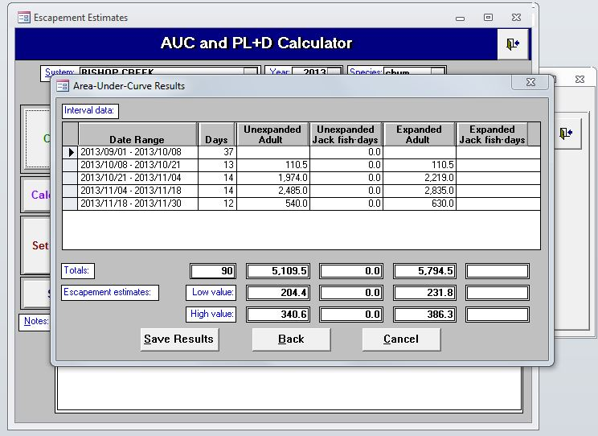

This screen allows the analyst to review the results of the AUC analysis one last time. If the analyst agrees with the results they can click on “Save Results” which will save this analysis in the database. If the analyst disagrees with the results they can click on “Back” which will take them to the previous screen where they can make changes if necessary.

5.3 Peak Live+Dead Calculator

Click on the Calculate Peak L+D button if you would like to compare the AUC results with the Peak Live +Dead results. The Peak Live+Dead results are listed as Raw and Expanded.

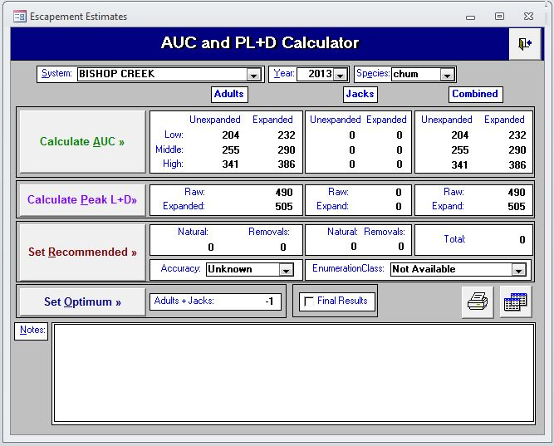
Calculate Peak Live and Dead

5.4 Set Recommended

This is the Final and Critical Step in choosing which method you will use for the escapement estimate. Click on the “Set Recommended” button which will display the following screen.

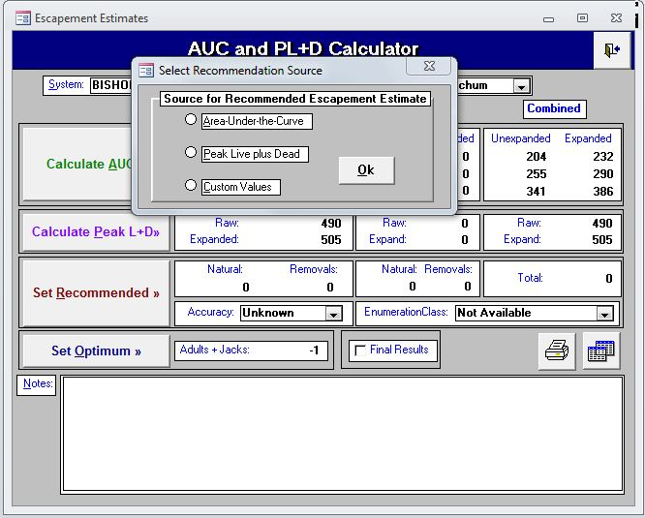
Set Recommended

Click on which method you would like to use for the escapement estimate, the choices include:
Area Under The Curve, Peak Live plus Dead, or Custom Values.

Custom Values. The Custom Values option would be chosen if you feel that the data was of such poor quality that you couldn’t do a proper escapement estimate. When you click on the custom values button the following screen will appear asking the analyst to “Enter recommended adult escapement estimate”. The default is 0 but a custom number can be entered in.

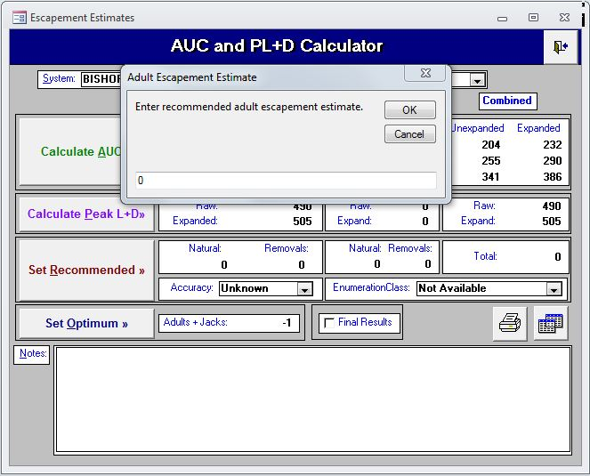

If you press “OK” with the default value of 0 the following screen will appear asking the analyst to “Enter recommended jack escapement estimate”. The default is 0 but a custom number can be entered in.

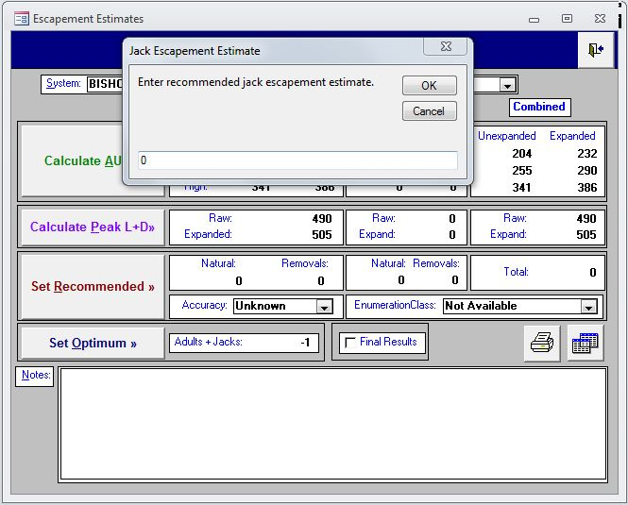

If you press “OK” with the default value of 0 the following screen will appear asking the analyst to enter in any adult or jack removals, default value is 0. Once you have finished entering in any removals (if appropriate) click on “OK”.

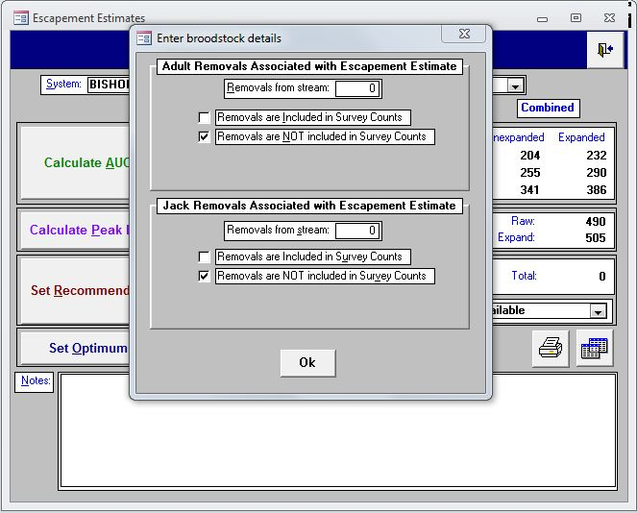
The following screen will appear where you can choose the most appropriate description for the zero estimate which includes: None Observed, Unknown, Stream Not Inspected, Species does not spawn in this stream, Fry present or Adults present. Once you make your choice click on “OK”. This completes the AUC & PL+D calculator portion.

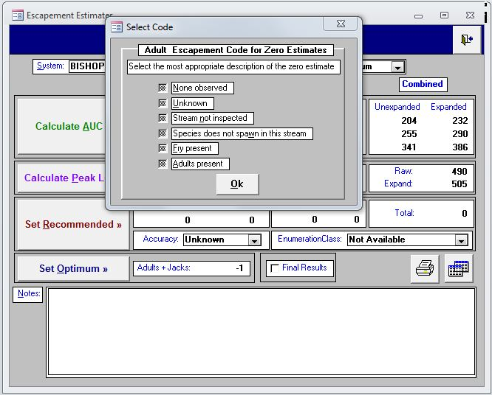

6.0 OTHER FEATURES

6.1 Error Check

The error check tab allows the user to perform error checks on SIL and AUC data in the database.

Step 1. To perform SIL error checks press on the Find SIL Duplicates button.
Step 2. To perform AUC error checks press on Find AUC Duplicates button.

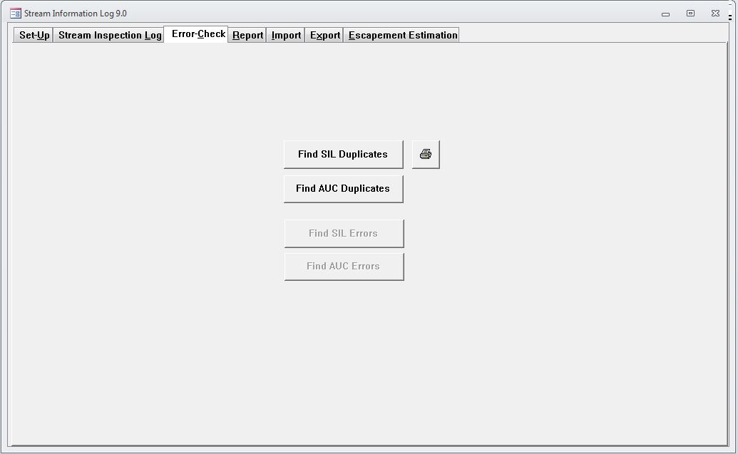
Step 1
Step 2

6.2 Report

The Report tab allows the user to view and print three different types of Stream Reports. The user is able to select individual or multiple stream reports.

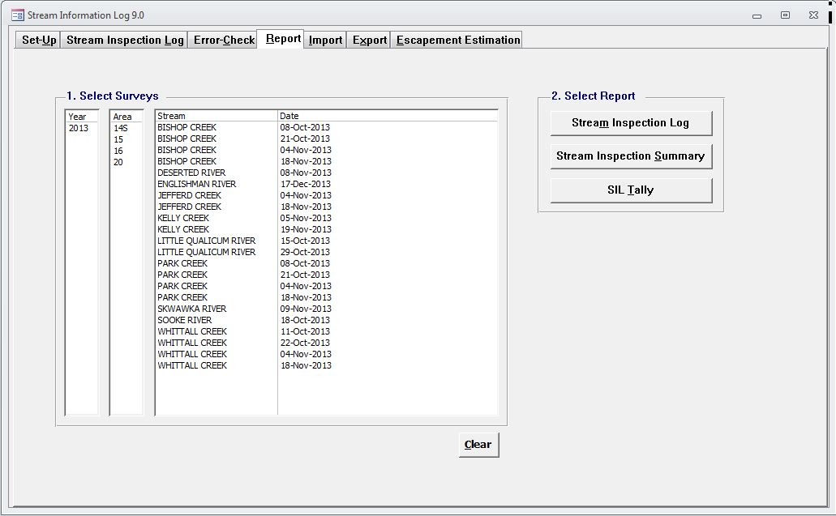

6.3 Importing Data

The import Tab allows the user to import SIL+AUC data from other SIL/AUC backend databases. The user has the option to import SIL+AUC data, SIL data only or AUC data only. Follow the numbers in order to perform data imports and error checks.

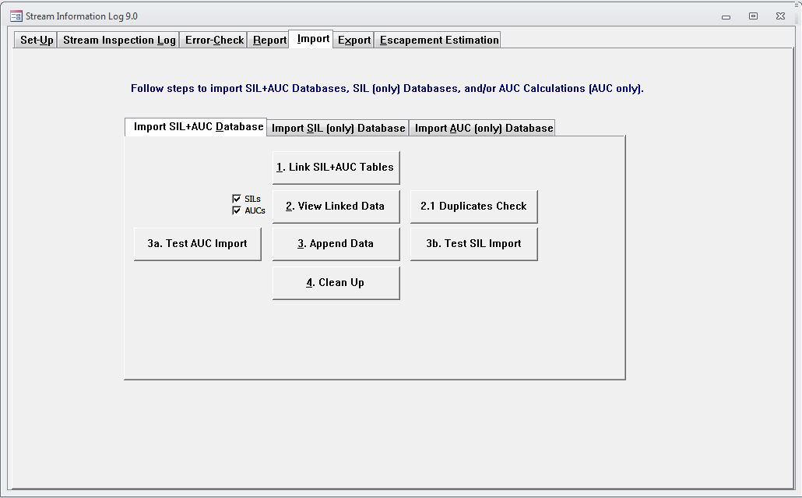

6.4 Exporting Data

The Export function allows the user to export SIL data by e-mail. Follow Steps 1-3 to export data. Once these data are received by the NuSEDS Data Custodian they will be uploaded into the NuSEDS database. The Export function may or may not be used depending upon whether the back-end databases are sent to the NuSEDS Data Custodian at the end of the field season and following data verification by the escapement analyst.

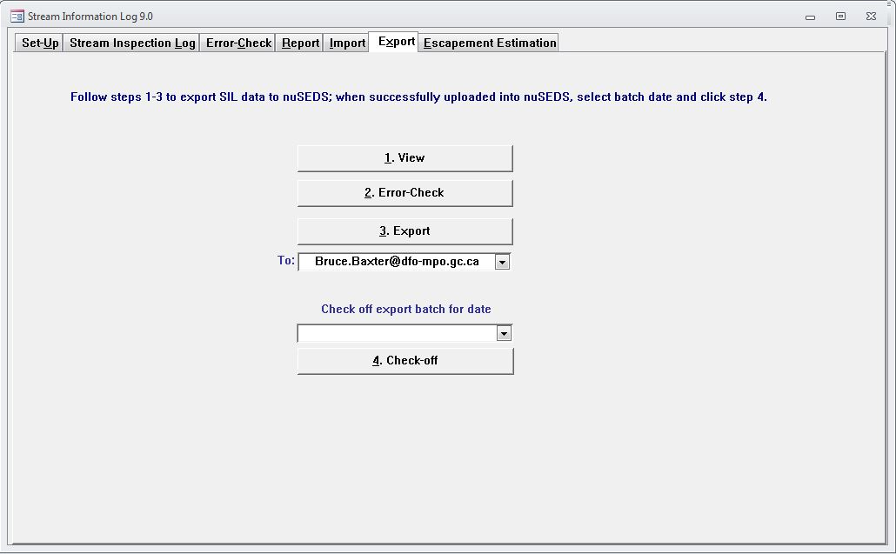

APPENDIX A- GROUND LEVEL SIL FIELD DEFINITIONS

Ground Level Stream Inspection Log Definitions
Field No. | Field Name | Definition
SECTION 1 : INSPECTION DETAILS
1.00 | INSPECTION DETAILS | This header section contains details identifying the stream, those carrying out the survey, type of inspection and environmental conditions. If any of these change significantly during the inspection a new SIL must be filled out. For example, an inspection of a clear (high water clarity) stream meeting a glacial (low water clarity) tributary may significantly impact fish visibility warranting a new SIL.
1.01 mandatory | Reference Code | This is an identifying code to record the date of the inspection and to link all associated sheets. The reference code is recorded as the first three letters of the stream, date of inspection, observer 1's initials and the SIL number. The SIL number is "1" for the first SIL of an inspection, "2" for the second and so on. For example, Jon Smith (observer 1) surveying Salmon River on July 18, 2000 would provide a reference code SAL-2000-07-18-JS-1. If during the inspection he had to fill out another SIL due to changing observing conditions (see INSPECTION DETAILS definition above) then there would be 2 SILs with reference numbers SAL-2000-07-18-JS-1 and SAL-2000-07-18-JS-2. To avoid identical reference codes when more than one stream with the same first three letters is inspected by the same observers on the same day, use an alternate first three letters. For example, if Nanaimo River and Nanoose River are done on the same day then one reference code could start as NA1-... and the other as NA2-...
1.02 mandatory | Stream Name | This is the name of the stream or water body being surveyed. Use the gazetted name or, if not gazetted, then use the DFO local name.
1.03 | Statistical Area | DFO Statistical Management Areas.
1.04 | Watershed Code | Enter the Provincial Watershed Code. Provincial watershed codes are available at the MELP website http://http://www.bcfisheries.gov.bc.ca/fishinv/db/default.asp. It is the intent to have provincial watershed codes for all surveyable streams in BC.
1.05 mandatory | Time Start | This is the time the inspection began. Use the 24 hour format (e.g. enter 1630 for 4:30 PM).
1.06 mandatory | Time Stop | This is the time the inspection ended. Use the 24 hour format (e.g. enter 1630 for 4:30 PM).
1.07 | Participants | This section records all the people involved in the inspection
1.08 mandatory | Observer 1 | This is the name of the person responsible for and conducting the inspection.
1.09 | Observer 2 | This is the name of other person(s) participating in the inspection.
1.10 | Affiliation | This is the name of the company/organisation that Observer 1 is associated with (e.g. DFO, First Nations band name, consulting company).
1.11 | Stock Assessment Contact | This is the federal or provincial stock assessment field co-ordinator who receives SILs and raw field records, and has knowledge of the assessment surveys.
1.12 | Stock Assessment Agency | This is the name of the government organisation that the stock assessment contact belongs to (e.g. DFO-Stock Assessment Division, DFO Resource Management, BC Ministry of Agriculture, Food and Fisheries - Fisheries Inventory Section).
1.13 mandatory | Primary Purpose | This is the main purpose for doing the inspection. Some categories are: spawner counts, proxy counts (e.g. redds), biosamples, calibration, habitat referral, habitat assessment, enforcement investigation, opportunistic, other (specify).
1.14 mandatory | Target Species | This is the species on which most enumeration effort is focused. Timing, methodology and location should be appropriate for the target species. If you wish to record more than one species be sure that the amount of enumeration effort put towards each of those species is the same.
1.15 mandatory | Number of stream segments included in this inspection: | This is the number of stream segments included in this inspection. For example entering 4 in this field means that four (2.0) OBSERVATIONS BY SEGMENTS sections have been completed.
1.16 mandatory | Primary Inspection Mode | This is the main method that is used during the inspection.
1.17 mandatory | Mode as per Narrative | This asks if the mode of inspection was performed as described in the Stream Narrative. If the answer is no, a reason must be supplied in the COMMENTS AND MAPS Section. Possible reasons include: no Stream Narrative available, bad/poor weather conditions, poor visibility, time constraints.
1.18 | Water Properties | The water conditions that influence fish visibility.
1.19 | Water Properties: %Bankfull | 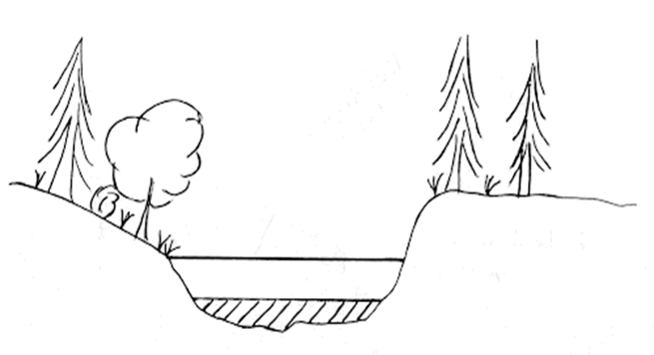  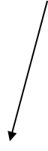  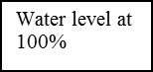  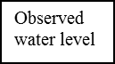  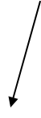  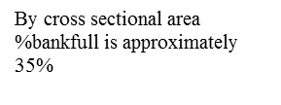
  %Bankfull refers to the % of the channel that is full. To determine this, visualise the cross sectional area of the stream as if it was full (water up to the permanent vegetation on the banks). Then estimate the percentage of this cross sectional area that is currently taken up by water. When choosing a location for estimating %bankfull, pick glide areas (areas of the stream with smooth flowing water) instead of riffles or pools, use the same “station” (if possible) for providing this estimate on all subsequent surveys and identify the %bankfull station on the stream survey reference map. Entries are less than 25%, 25-50%, 50-75%, 75-100%, greater than 100%
1.20 | Water Properties: Gauge Height | This is the depth at a known reference point in meters.
1.21 | Water Properties: Discharge | This is the discharge at a known reference point in cubic meters per second.
1.22 | Water Properties: Water Temp. | This is the temperature of the water in degrees Celsius.
1.23 | Water Properties: Water Clarity | This is an indication of how visible the fish are. It should be estimated at a location where you cannot see the bottom. This could be based on Secchi disc reading or a visual estimation in the deepest water. If the bottom is visible throughout the area surveyed then choose 3m-5m or to bottom. If greater than 5 meters then specify depth. For snorkel inspections water clarity should be estimated horizontally at a location where you cannot see the opposite bank.
1.24 | Sky Condition | This is the average sky condition during the inspection and is meant to give a measure of light conditions that will influence fish visibility.
1.25 | Sky Condition: %Cloudy | The percentage of visible sky that is filled by clouds.
1.26 | Sky Condition: Brightness | This quantifies the amount of light reaching the water surface. This is influenced by factors such as cloud thickness and overhead tree canopy.
1.26 | Sky Condition: Brightness | Full = direct sunlight. Shadows are well defined.
1.26 | Sky Condition: Brightness | Bright = hazy or light cloud cover, outline of sun visible, shadows are poorly defined.
1.26 | Sky Condition: Brightness | Medium = cannot see the outline of the sun; no shadows, yet there is a distinguishable bright area of the sun in the sky.
1.26 | Sky Condition: Brightness | Dark = no outline of the sun, no shadows and no distinguishable bright area of the sun in the sky.
1.27 | Precipitation | This is an average indication of rain and/or snow conditions during the inspection that will influence fish visibility.
1.28 | Precipitation: Type | This describes the type of precipitation.
1.29 | Precipitation: Intensity | This describes the intensity of precipitation. Do not tick any boxes if None is chosen for the precipitation type.
1.30 | Air Temp | This is a measure of the air temperature in degrees Celsius.
1.31 mandatory | Stream Visibility | This is a classification of the average visibility of the fish as influenced by water properties, sky conditions and precipitation during the inspection. If there is a significant long lasting change in environmental conditions affecting stream visibility during the inspection then another SIL should be filled out.
SECTION 2 : OBSERVATIONS BY SEGMENT
2.00 | OBSERVATIONS BY STREAM SEGMENT | This section contains the observations by stream segment which could be the entire stream or a portion thereof. If the stream is divided into segments then this section 2 must be completed for each segment.
2.01 mandatory | Segment ID | This is the descriptor normally assigned to this segment as documented in the Stream Narrative or as applied on this inspection if no Stream Narrative is available. If the inspected segment consists of a combination of more than one of the segments described in the Stream Narrative then list the combined segment identifiers. If the segment is the whole stream then record the stream name.
2.02 mandatory | Segment details as per Narrative | This asks if the Start Boundary, Stop Boundary and Distance Inspected fields of the inspected stream segment are as described in the Stream Narrative. If they are then the yes box can be ticked and those fields need not be entered. If the segment details differ from those in the Stream Narrative, then these fields must be filled out and an explanation provided in the COMMENTS AND MAPS section. Examples include, boundaries shifted due to channel changes, boundary marker missing, boundary marker missed. If the Stream Narrative needs to be changed then indicate changes.
2.03 | Segment Type | Segments can be one of several types. Stream / natural channel includes mainstem and natural side channel observations.
2.03 | Segment Type | Artificial Channel includes observations in human-made habitats where there are persistent engineered features (e.g. Horsefly, Pinkut, Nekite, Fulton spawning channels).
2.03 | Segment Type | Tidal Estuary includes observations that are made seaward of the river mouth where fish are destined to migrate up the stream being inspected (e.g. a segment may extend from the river mouth out to where the bottom suddenly drops off and another may be from the drop-off to sport fish boundaries / commercial boundaries).
2.03 | Segment Type | Lake includes observations made in holding areas and/or on spawning beaches.
2.03 | Segment Type | Slough includes observations made in habitat with little or no flow.
2.04 | Start Boundary: | This is a description of where an observed segment starts. It can either be a permanent landmark or be described by coordinates. It must be sufficient to be repeatable in following years and will require the creation of a map or reference to an existing one as recorded in the Stream Narrative. For example, boundaries could start at the lowest downstream point and are sequentially described using alphanumeric notation (e.g. B₀ = furthest downstream boundary, B₁ = the next upstream boundary). Segments are the lengths of stream between two boundaries and receive alphanumeric notation as well (e.g. S₁ would be bounded by B₀ and B₁. Reference to a map would be useful in complex situations (e.g. braiding, channelization).
2.05 | Start Boundary: Coordinates | This field records the latitude and longitude coordinates (e.g. 51° 20.9'N 126° 07.4'W) of the start boundary, or if unavailable, the UTM coordinates (e.g. Zone 10, E486005 N5440487).
2.06 | Stop Boundary: | This is a description of where an observed segment ends as described above in Start Boundary.
2.07 | Stop Boundary: Coordinates | This field records the latitude and longitude coordinates (e.g. 51° 20.9'N 126° 07.4'W) of the stop boundary, or if unavailable, the UTM coordinates (e.g. Zone 10, E486005 N5440487).
2.08 | Datum | This is the "origin" to which your UTM grid coordinates are referenced (e.g. NAD27, NAD83).
2.09 | Coordinate Source | This specifies where the coordinates come from. This could be, for example, a GPS (including make / model,) or a map (including scale, series).
2.10 | Distance Inspected | This is the length of segment covered in the observation (meters) as measured from a map, hip chain, aerial photo, etc. If a portion of the segment was not inspected then do not include its length. For example, if the segment length is 500 m, but 200m could not be inspected due to new log jam then the distance inspected is 300m.
2.11 | Species | This is the species of fish observed. There are two columns of space to accommodate fish species other than the five species of salmon commonly inspected.
2.12 | Stock/Run Type | This is the run timing or life history component (e.g. early, late, spring, summer, fall, winter) used to distinguish two different runs of the same species in the same stream. For example, summer steelhead versus winter steelhead. If unknown leave blank.
2.13 | Adults (not jacks) | This includes all salmon that have reached maturity, excluding jacks (jacks are salmon that have matured at an early age).
2.14 mandatory | Adults (not jacks): Adult Presence | This is a mandatory field where only one choice is selected. The field is meant to identify whether live or dead adults of a given species have been detected during this inspection. The observer(s) are encouraged to report on what is seen and make a selection for as many salmon species as possible, not just those identified in Target Species field in section 1. The descriptors used are NO and AP.
2.14 mandatory | Adults (not jacks): Adult Presence | NO = none observed; the species was looked for, but neither live nor dead fish were observed or did not/could not look for this species even if the species was present. If NO has been recorded, then zeroes do not need to be entered in that column.
2.14 mandatory | Adults (not jacks): Adult Presence | AP = adults present; the inspection was conducted for this species and adults were present. For example, if pinks were seen, but no counts were made then check AP for adults present and do not enter any adult numbers in that column. If able to supply adult counts then record them in the column below.
2.15 | Adults (not jacks): Live: Holding | This is the number of fish that are not paired nor actively spawning. This number may be zero if there are no fish present or if all fish are spawning and/or dead. If NO has been checked off in Adult Presence a zero is not required.
2.16 | Adults (not jacks): Live: Spawning | This is the number of fish that are paired and/or actively spawning. If NO has been checked off in Adult Presence a zero is not required.
2.17 | Adults (not jacks): Live: Observed | This is the number of fish actually observed in the stream segment.
2.18 | Adults (not jacks): Live: Estimated | This is an estimation of the number of live fish thought to be in the segment and includes the observed count plus the number of live fish that the observer feels were in the segment, but were not observed. Unseen fish could be in areas such as: under cutbanks, log jams, deep water or side channels.
2.19 | Adults (not jacks): Live: %New | This is an estimate of the percentage of fish that have recently arrived to the stream, ranging from 0% to 100%. This can be based on numeric differences between inspections or on the physical condition of the fish in this inspection. New fish are usually bright fish with no fungus or white-coloured, eroded fins.
2.20 | Adults (not jacks): Live: Rationale for Estimated: | This is an explanation for the inclusion of unobserved fish that were recorded in the Estimated row above.
2.21 | Adults (not jacks): Dead: Observed | Number of dead adult fish observed in the segment. Dead fish include all carcasses that can be identified to species and are reasonably complete (e.g. not just a fragment of spine). If NO has been checked off in Adult Presence a zero is not required.
2.22 | Adults (not jacks): Dead: Estimated | This is an estimation of the number of dead fish thought to be in the segment and includes the observed count plus the number of dead fish that the observer feels were in the segment, but were not observed. These areas could include under cutbanks, log jams, deep water or side channels.
2.23 | Adults (not jacks): Dead: % Pre-Spawn Dead | This is the percentage of adult fish that died prior to spawning (I.e. gonads intact as detected by incision).
2.24 | Adults (not jacks): Dead: Rationale for Estimated: | This is an explanation for the inclusion of unobserved fish that were recorded in the Estimated row above.
2.25 | Jacks | These are fish that have matured at an early age and are considered precocious. They are usually distinguished from adults by their small size.
2.26 | Jacks: Live | This is the number of live jacks observed.
2.27 | Jacks: Dead | This is the number of dead jacks observed.
2.28 | Number of Redds | This is the number of counted redds (occupied and unoccupied).
2.29 | Bears | This section contains observations of grizzly bears and black bears.
2.30 mandatory | Bears: Assessed | This indicates whether bear observations were made. If you select yes with no observations then it is assumed that bears were considered during the inspection, but none were observed.
2.31 | Bears: Seg ID | This indicates in which stream segment the bear observation was made.
2.32 | Bears: Obs | This is the observation number in the segment. One observation is either 1 family group (e.g. 1 adult female and accompanied young) or 1 individual bear. If more than one adult bear is present, then multiple observations are recorded.
2.33 | Bears: Species | This describes the species of observed bear: B=black bear, G=grizzly bear or U=Unconfirmed. A grizzly is distinguished by a hump behind the neck above the shoulders.
2.34 | Bears: Age | This describes the approximate age of the bear: A=Adult, SA=Subadult or U=Unconfirmed. If cubs but not the mother are seen, assume the female is present and record in Section 7 Comments with the Observation Number.
2.35 | Bears: Sex | This is the sex of the bear: M=Male, F=Female or U=Unconfirmed.
2.36 | Bears: Attended Young | This is the number of juveniles accompanied by a single adult female. If the female is not seen, record this in the comments. Cubs are quarter the height of the female, yearlings are approximately half the size of the female and 2 year-olds are 75%-100% the size of the female.
2.37 | Other non-fish observed: | Record the type and number of other subjects (4 bears, 12 eagles, 3 anglers, etc.). Avoid using qualitative terms like "few" or "a lot".
SECTION 3 SUMMARY FOR THIS INSPECTION
3.00 | SUMMARY FOR THIS INSPECTION | This section includes the total of observed and estimated number of fish in the stream identified in section 1 for this inspection. This could be the total of all section 2 information or the total plus an adjustment for unobserved segments. In some cases, in-stream summary estimates are for segment sets describing less than the total habitat available to the species (e.g. streams where estimates are traditional spawner abundance indices and do not describe the total escapement to the stream). Make sure to explain in Explain %Population or (if more room is required) the Comments section, exactly which portions of the stream are/are not included. The section also addresses spawning details, overall reliability and distribution information.
3.01 | Species | This is the species of fish being estimated. There are two columns of space to accommodate fish species other than the five species of salmon commonly inspected.
3.02 | Stock/Run Type | This is the run timing or life history component (e.g. early, late, spring, summer, fall, winter) used to distinguish two different runs of the same species in the same stream. For example, summer steelhead versus winter steelhead. If unknown leave blank.
3.03 | %Population | This is the proportion of the in-stream population (adults and jacks) for this inspection that was accounted for in the OBSERVATIONS BY SEGMENT section(s). This is not necessarily the same as the percentage of the stream that was inspected. Therefore, for a defensible value, you must know the spawning and holding distribution of each species. For example, the sum of all section 2 combined totals may represent 80% of the total in-stream population at the time of inspection. Record 80% in this field. If all current spawning and holding areas have been inspected then the percent population is 100%.
3.04 | Adults (not jacks): Adult Presence | If section 3 is filled out then this is a mandatory field where only one choice is selected to identify whether live or dead adults of a given species have been detected during this inspection. The observer(s) are encouraged to report on what is seen, not just those identified in Target Species field in section 1. Descriptors used are NO and AP.
3.04 | Adults (not jacks): Adult Presence | NO = none observed; species was looked for, but neither live nor dead fish were observed or did not/could not look for this species even if the species was presumed to be present. If NO has been recorded, then zeroes do not need to be entered in that column.
3.04 | Adults (not jacks): Adult Presence | AP = adults present; inspection was conducted for this species and adults were present. If you are able to supply adult estimates then check AP and record estimates in the column below. If you are unable to supply estimates, but have observed adults then check AP and leave the rest of the column blank. For example, if a portion of the stream was inspected and numbers were recorded in the Estimated fields (Section 2), but the spawning distribution of the species is not well known then only recording AP is acceptable.
3.05 | Adults (not jacks): Live Total In: Segments Observed | This is the total number of live adults of each species actually observed during this inspection and is calculated by summing all section 2's live Observed
3.06 | Adults (not jacks): Live Total In: Segments Estimated | This is the total number of live adults of each species estimated to be present in the inspected portions of the stream and is calculated by summing all section 2's live Estimated.
3.07 | Adults (not jacks): Live Total In: Stream Estimate | This is the total number of live adults of each species estimated for this inspection calculated by summing all section 2 live Estimated recorded values and applying any expansion resulting from %Population. For example, if five stream segments are inspected and the sum of Estimated for a species from all five section 2's is 10,000, and the %population is 80% then the Stream Estimate is 12,500.
3.08 | Adults (not jacks): Dead Total In: Segments Observed | This is the total number of dead adults of each species actually observed during this inspection and is calculated by summing all section 2's dead Observed.
3.09 | Adults (not jacks): Dead Total In: Segments Estimated | This is the total number of dead adults of each species estimated to be present in the inspected portions of the stream and is calculated by summing all section 2's dead Estimated.
3.10 | Adults (not jacks): Dead Total In: Stream Estimate | This is the total number of dead adults of each species estimated for this inspection calculated by summing all section 2 dead Estimated recorded values and applying any expansion resulting from %Population. For example, if five stream segments are inspected and the sum of Estimated for a species from all five section 2's is 10,000, and the %population is 80% then the Stream Estimate is 12,500.
3.11 | Jacks: Jack Presence | This field is meant to identify whether live or dead jacks of a given species have been detected during this inspection. Descriptors used are NO and JP.
3.11 | Jacks: Jack Presence | NO = none observed; species was looked for, but neither live nor dead fish were observed or did not/could not look for this species even if jacks were presumed to be present. If NO has been recorded, then zeroes do not need to be entered in that column.
3.11 | Jacks: Jack Presence | JP = jacks present; inspection was conducted for this species and jacks were present. If jacks were seen, but no estimates were made then check JP for Jack Presence and do not enter any jack numbers in that column. If able to supply jack estimates then check JP and record estimates in the column below.
3.12 | Jacks: Live | This is the total number of live jacks of each species estimated for this inspection.
3.13 | Jacks: Dead | This is the total number of dead jacks of each species estimated for this inspection.
3.14 | Total Number of Redds | This is the total number of observed redds of each species for this inspection.
3.15 | Spawning | This is an indication of what stage in the spawning period the species has reached at the time of inspection.
3.15 | Spawning | Before means zero fish have arrived at their spawning grounds.
3.15 | Spawning | Start means fish are beginning to pair on the spawning grounds, schools of fish may be holding (pools or mouth) and there are very few, if any, carcasses or redds. Fish are generally in the lower sections of the normal spawning area and may be bright with no fungus and have no white-coloured, eroded fins.
3.15 | Spawning | Peak means the majority of the fish present are paired and actively spawning with few fish holding. The fish may have fungus or white-coloured, eroded fins. A significant proportion of the spawning grounds should have evidence of redds and the fish should generally be distributed throughout the spawning area.
3.15 | Spawning | End means very few fish are on the spawning grounds, few unspawned fish are holding and there are lots of carcasses. The remaining fish will likely occupy the upper reaches of the spawning area.
3.16 | Peak Spawning Date | This is an estimate of the peak spawning date for this species during the current year. This is based on expert opinion or previous inspections.
3.17 | Reliability | This is the observer's opinion of the overall reliability of the estimate for this inspection. It should be based on the Section 1 environmental conditions and possibly %Population. For example, if Stream Visibility was high and the majority of the population was observed then Reliability should be high. If the above was true, but there was difficulty in distinguishing the species then the reliability should be lower.
3.18 | Distribution | This describes the distribution of salmon in the stream.
3.18 | Distribution | Mouth means fish are in the downstream end of the stream.
3.18 | Distribution | Lower means fish are in the downstream segments of the stream.
3.18 | Distribution | Evenly throughout means fish are not concentrated in any part of the stream and are found in all segments.
3.18 | Distribution | Upper means fish are in the upstream segments of the stream.
3.19 | Explain %Population | If %Population is less than 100% then explain which portions of the stream were not inspected and why. In some cases, in-stream summary estimates are for segment sets describing less than the total habitat available to the species (e.g. streams where estimates are traditional spawner abundance indices and do not describe the total escapement to the stream). Make sure to explain in Explain %Population or (if more room is required) the Comments section, exactly which portions of the stream are/are not included.
SECTION 4 UNUSUAL CONDITIONS
4.00 | UNUSUAL CONDITIONS | This section describes significant deviations from the norm associated with assessment of fish, climate, or habitat that have not been recorded in a previous inspection. If any of these condition fields are selected then elaboration (type, locations severity, etc.) is required in the Comments Section.
4.01 mandatory | Fish Assessed | This indicates whether any unusual fish conditions were considered.
4.02 | Pre-Spawn Mortality | This is used to record unusually high or unusually low numbers of adult fish that died prior to spawning. Prespawn mortality is indicated by intact gonads which are best detected by incision.
4.03 | Disease/Parasites | This is an indication of unusual presence or absence of fish diseases or parasites.
4.04 | Sex Ratio | This is an indication of an unusually high proportion of males or females. Visual determination may be difficult. Carcasses may be used to determine abnormal sex ratios. Sex ratios of live fish may be determined provided there is a clear distinction between males and females using size, shape and/or colour.
4.05 mandatory | Stream Assessed | This indicates whether any unusual stream conditions were considered.
4.06 | Recent Flood | This indicates that a flood of unusually high magnitude has recently occurred. An unusual flood produces changes to the channel or enough bedload movement to significantly scour redds and eggs.
4.07 | Drought | This is an indication of conditions dry enough to impede normal fish migration/spawning or to result in the desiccation of redds and eggs.
4.08 | Ice Conditions | This is an indication of freezing conditions that could result in a significant loss of eggs. These conditions would occur when ice has formed in the gravel and is impeding water flow.
4.09 | Water Temp | This is an indication of water temperature well above or below the seasonal norm. For example, in the winter this may be a 2 degree Celsius difference, while in summer this may be a 5 degree difference.
4.10 mandatory | Habitat Assessed | This indicates whether any unusual habitat conditions were considered.
4.11 | debris, jams/obstructions | This is an indication of the appearance of unusual debris that results in jams or obstructions appearing since the last inspection.
4.12 | silting of spawning beds | This is an indication of an unusual deposition of fine particles sufficient to smother eggs.
4.13 | bank erosion | This is an indication of unusual new stream side degradation.
4.14 | riparian cover loss | This is an indication of unusual of the loss of stream side vegetation.
4.15 | loss of debris jams/obstructions | This is an indication of the loss of debris that results in the elimination of jams or obstructions since the last inspection.
4.16 | slides | This is an indication of an unusual slope failure resulting in the deposition of large amounts of materials into the stream.
4.17 | stream bed movement | This is an indication of unusual bed load movement that results in sediment loss or deposition. This may include the relocation of stream channels.
4.18 | Other Unusual Conditions | This is an indication of some other unusual condition not captured above.
SECTION 5 BIOSAMPLES TAKEN DURING THIS INSPECTION
5.00 | BIOSAMPLES TAKEN DURING THIS INSPECTION | This section is meant to identify whether biosamples were taken in association with this inspection. Identify the species and type of biosample. If the biosamples were collected for someone other than the Stock Assessment Contact then specify the responsible agency, location and person in the Comments and Map section.
5.01 | Species | This is the species of the fish from which biosamples are taken.
5.02 | Biosample Type | This indicates the type of biosample. Choices are Scales, Otoliths, Ovaries, Length, DNA, Tags/Marks, Other. For Tags/Marks specify the tag (CWT, petersen disc) and/or mark(e.g. fin clip, brand) in the Biosampling Details column if known. If the reason the tag/mark was applied is known then record this in the Comments and Maps Section. Other types include fin rays, parasites, pathogens, eggs. These should be specified in the Biosampling Details space.
5.03 | Biosampling Details | This is where additional information about the biosamples is recorded. Identify, for example, the number of samples taken, coding used (such as scale book numbers, DNA sample type, tag numbers).
SECTION 6 VISUAL RECORDS
6.00 | VISUAL RECORDS (photos, maps, video, etc.) | This section is for the documentation of any visual records created during this survey. These records provide supplementary information to any of the fields on the form. It is intended that this information be used to aid in the development of the stream narrative or in the interpretation of the inspection. Record Type and contact details must be specified to facilitate retrieval. If the visual records were supplied by someone other than the Stock Assessment Contact then specify the responsible agency, location and person in the Comments and Map section.
6.01 | Record Type | This includes records such as but not limited to: photos, maps, videos.
6.02 | Record Details | This includes details such as scale, map/photo series, map/photo numbers and any other information that helps to identify and retrieve the record.
SECTION 7 COMMENTS AND MAP
7.00 | COMMENTS AND MAP | This section is used to record additional comments and/or to diagram the survey location. Draw or attach a sketch of the sections surveyed. Record any other pertinent comments. Use the field number when recording specific comments.
7.01 | Form Code | This indicates which field is being commented on. For example, 4.16 might be followed by an explanation of where a slide occurred, the extent and what caused it.
7.02 | Notes | This is a free form area where comments and/or maps can be recorded/sketched. Comments should ideally be paired with a form codes ranging from 1.00 to 6.02

APPENDIX B- AERIAL SIL FIELD DEFINITIONS

Aerial Single Species Stream Inspection Log Definitions
Field No. | Field Name | Definition
SECTION 1 : INSPECTION DETAILS
1.12 | Pilot | This is the person operating the aircraft.
1.18 | Aircraft Model | This is the model of the aircraft (e.g. Beaver)..
1.19 | Flight Direction | This is the main direction that was taken for the extent of the inspection. Choices are upstream or downstream.
1.21 | Flight Conditions | This information is important to collect in order to achieve consistency in further aerial inspections.
1.22 | Flight Conditions: Air Speed | This is the speed of the aircraft relative to the air and is not ground speed.
1.23 | Flight Conditions: Wind | This is an estimation of the wind speed at the location of the inspection.
1.24 | Flight Conditions: Altitude | This is an estimation of the height of the aircraft above the water being inspected.
 |  | 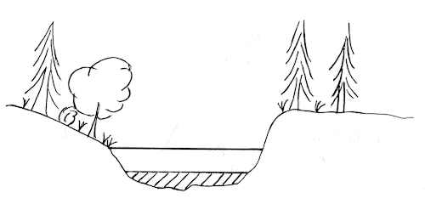
SECTION 2 : OBSERVATIONS BY SEGMENT (ADULTS, NOT JACKS)
2.11 | Flight Direction | This is the main direction that was taken for the extent of the segment. Choices are upstream or downstream.
2.12 | Tree Canopy | This describes the amount of tree cover between the observer and the water.
2.12 | Tree Canopy | Open means that 100% of the stream channel width (bank to bank) is visible.
2.12 | Tree Canopy | 100-75% means that up to 25% of the bank to bank visibility is obscured by tree canopy.
2.12 | Tree Canopy | 75-50% means that 25 to 50% of the bank to bank visibility is obscured by tree canopy.
2.12 | Tree Canopy | 50-0% means that 50 to 100% of the bank to bank visibility is obscured by tree canopy. This amount of obscurity would probably only result in an "Adult Presence" level of observation.
2.19 | Empty Redds | These are redds that are unoccupied. Occupied redds are difficult to identify from the air so do not include them in the count.

APPENDIX C- SEN FIELD DEFINITIONS

Summary Estimate Narrative Definitions (Standard Fields)
Field Number | Field Name | Field Definition
1 | DESCR | Concatenation of population name and analysis year
2 | PROJECT | New projects are created each year, but can be created at any time to group data. E.g. South Coast Enumeration (2003).
3 | AREA | This is the subdistrict. In most cases subdistricts are the same as statistical areas. They mainly differ for streams that eventually drain into the Fraser and for large areas that have been split up and thus have a/b/c... designations. E.g. Statistical area 03 has two subdistricts 3A and 3B.
4 | GEOGRAPHICAL_EXTNT_OF_ESTIMATE | This is the name of the waterbody or portion of a waterbody that bounds the population as shown on any given SEN
5 | GAZETTED_NAME | Provincially recognized name for the waterbody
6 | LOCAL_NAME_1 | Commonly known name for the waterbody
7 | LOCAL_NAME_2 | Second most commonly known name for the waterbody
8 | WATERSHED_CDE | 45 digit hierarchical provincial code unique to the waterbody and its watershed
9 | WATERBODY_ID | This is a combination of 5 digits that uniquely identify a GIS polygon and four characters that uniquely describe a provincial watershed group.
10 | RAB_CDE | Discontinued Resource Analysis Branch Code unique to each waterbody.
11 | TIME_SERIES | This describes a group of estimates over time that have similar precision/accuracy and utility. Historic estimates that were imported from nuSEDS1 were all given a default time series because their metadata were unknown.
12 | SPECIES | self explanatory
13 | POPULATION | Default naming originates from previous databases as a concatenation of stream name, subdistrict, species and run type. This is the most important piece of data that all the other SEN data fields refers to.
14 | START_DTT | This is the time stream inspections began e.g. 2000-10-15 means that the first inspection for this season's estimate started on October 15 2000.
15 | END_DTT | This is the time stream inspections ended e.g. 2000-11-15 means that the last inspection for this season's estimate started on November 15 2000.
16 | ESCAPEMENT_ANALYST | Person responsible for estimate(s) on this SEN.
17 | ANALYSIS_YR | This is the year that the estimate is for. Surveys may have continued into the following calendar year.
18 | ACCURACY | This is the ability of a measurement to match the actual value of the quantity being measured. Some historical estimates that were imported had reliability data originating from SEDS that may appear here.
19 | PRECISION | This is the ability of a measurement to be consistently reproduced, or put another way, the number of significant digits to which a value has been reliably measured.
20 | RELIABILITY | This field was added for the inclusion of historical data from an external source. It is the level of reliability that the person placed in their annual estimate of adults. Since this was only recorded for some historical BC16s it will not be visible in all cases. Values are low, medium low, medium, medium high and high.
21 | INDEX_YN | This indicates whether the estimates are for a portion of the population. This is usually due by purposely limiting enumeration to a portion of the spawning habitat or a portion of the duration of the run.
22 | ESTIMATE_STAGE | Preliminary SENs are the first drafts of summary estimate documents. Source data may be incomplete and their accuracy has not been verified. Significant changes from Preliminary estimates are probable.  Near Final SENs are based on data that have been verified for completeness and accuracy. Further analysis may take place. Final data verification and analysis have not been completed. Minor changes in Near Final estimates are possible.  Final SENs are released after all data have been incorporated into the analyses and all verification steps have been completed. Changes are not anticipated.
23 | ESTIMATE_CLASSIFICATION | This categorizes estimates based on their levels of accuracy and precision. See the Estimate Classification Key for standard definitions. There are three other classifications that belong to SENs whose source data were migrated from the regional MS Access SILBC16 database (definitions extracted from that user manual).  RELATIVE: CONSTANT MULTI-YEAR METHODS and  RELATIVE: VARYING MULTI-YEAR METHODS: "This is the case with survey methods restricted to a fraction of the spawning habitat and/or a fraction of the spawning period. There are various types of relative abundance estimates depending on the survey method, the level of standardization of the methods, and the sampling effort. For our purpose we have retained one type based on between-year consistency of the method where there are two levels."  NO SURVEY THIS YEAR: "stream was not inspected for that species this year"
24 | NO_INSPECTIONS_USED | This is the number of stream inspection logs that are linked to the SEN or were used in the analysis. E.g. 10 stream inspections and a fixed site survey may have been done in the season, but only 7 stream inspections and the fence counts will be used to produce the annual estimate(s), and only these are linked to the SEN.
25 | ESTIMATE_METHOD | There are several standard methods to chose from.  Addition/Subtraction - simple addition or subtraction to provide an estimate. Should be used in conjunction with activity types Adjustment/Calibration and Summary observations. E.g. a population aggregate, the sum of two or more populations, would require the linking of two or more SENs and straight summation of the estimates.  Multiplication/Division - simple multiplication or division to summary estimates. This method should be used in conjunction with activity type Adjustment/Calibration. E.g. E.g. An annual estimate that was arrived at by Peak Live Plus Dead analysis can be adjusted by some factor to make it equivalent to a Time Series estimate that uses AUC calculations.  Area Under the Curve - Combining a series of point estimates for abundance to create an estimate for the annual abundance. This is done by determining the total area under a curve of abundance by time then dividing by the survey life (the average length of time that an individual is available to be observed alive i.e. is still within the survey area and is not dead).  Peak Live Plus Dead - Examine point estimates for abundance, determine the survey when the maximum live count observed; sum the live and dead counts for that survey to create the annual estimate.  Peak Live Plus Cumulative Dead - Examine point estimates for abundance, determine the survey when the maximum live count observed. Sum the live count for that survey with the cumulative total of the dead counts prior to and including that survey to create the annual estimate.  Fixed Site Census - Combining one or more raw observations into a single estimate (e.g. add all daily fence observation SIL to create a single annual estimate).  Mark and Recapture - Petersen - Use capture and re-capture SIL data to determine an abundance estimate with the Petersen calculation.  Mark and Recapture - Jolly-Seber - Use capture and re-capture SIL data to determine an abundance estimate with the Jolly-Seber calculation.  Redd Count - Using counts of redds from SILs and multiplied by a factor such as 2.  Lake Expansion - expanding the dead recoveries by the recovery effort  Cumulative New - N/A
26 | CMNT | Explanations of analysis method used as well as general comments
27 | STREAM_ARRIVAL_DT_FROM | This is the start date when the fish first arrive in the water body described on the SEN Details page. Note that the spawn run timings are paired so that Arrival, Start, Peak, and End each have beginning and end date values to represent a date range. The following definition applies to SENs whose source data were migrated from the regional MS Access SILBC16 database applying mainly to areas 11 to 27, and Fraser chinook/coho, all from 1995 to 2001: "is defined as the month and days (period) that 5% of the fish arrived in the stream. If the number at peak spawning is known, you can identify any of your counts that correspond to 5% of that value. If so the date you made this observation will correspond to the arrival date."
28 | STREAM_ARRIVAL_DT_TO | This is the end date of arriving fish to the water body described on the SEN Details page.
29 | START_SPAWN_DT_FROM | This is the spawning start date for a population for the current season where start means fish are beginning to pair on the spawning grounds, schools of fish may be holding (pools or mouth) and there are very few, if any, carcasses or redds. Fish are generally in the lower sections of the normal spawning area and may be bright with no fungus and have no white-coloured, eroded fins. The following definition applies to SENs whose source data were migrated from the regional MS Access SILBC16 database applying mainly to areas 11 to 27, and Fraser chinook/coho, all from 1995 to 2001: "month and days (period) when fish are paired and redds are observed. "
30 | START_SPAWN_DT_TO | This is the end date of the start of spawning period. See above for the definition of this run timing period.
31 | PEAK_SPAWN_DT_FROM | This field records the Spawning Peak date for a population and a given season. Peak means the majority of the fish present are paired and actively spawning with few fish holding. The fish may have fungus or white-coloured, eroded fins. A significant proportion of the spawning grounds should have evidence of redds and the fish should generally be distributed throughout the spawning area. The following definition applies to SENs whose source data were migrated from the regional MS Access SILBC16 database applying mainly to areas 11 to 27, and Fraser chinook/coho, all from 1995 to 2001: "month and days (period) when the number of fish spawning reached its maximum. "
32 | PEAK_SPAWN_DT_TO | This is the end date of the peak of spawning period. See above for the definition of this run timing period.
33 | END_SPAWN_DT_FROM | This field records the Spawning End date for a population and a given season. End means very few fish are on the spawning grounds, few unspawned fish are holding and there are lots of carcasses. The remaining fish will likely occupy the upper reaches of the spawning area. The following definition applies to SENs whose source data were migrated from the regional MS Access SILBC16 database applying mainly to areas 11 to 27, and Fraser chinook/coho, all from 1995 to 2001: "month and days (period) when virtually all fish have spawned in the stream."
34 | END_SPAWN_DT_TO | This is the end date of the end of spawning period. See above for the definition of this run timing period.
35 | BEHAVIOUR_TYP | This describes the behaviour of the population at the time of assessment.
36 | SEN_PRESENCE_ADULT | Values are present if adults were observed, none observed if no adults were observed during the stream inspections, not inspected if adults were not looked for, unknown if it is not known whether adults were observed during inspections or not.
37 | SEN_PRESENCE_JACK | Values are present if jacks were observed, none observed if no jacks were observed during the stream inspections, not inspected if jacks were not looked for, unknown if it is not known whether jacks were observed during inspections or not.
38 | SEN_PRESENCE_FRY | Values are present if fry were observed, none observed if no fry were observed during the stream inspections, not inspected if fry were not looked for, unknown if it is not known whether fry were observed during inspections or not.
39 | NATURAL SPAWNERS | (Sexually maturing fish that have returned to the artificial / natural spawning grounds and have full potential to spawn and naturally pair.)
40 | SEN_NATURAL_SPAWNERS_ADULT | All salmon that have reached maturity, excluding jacks (jacks are salmon that have matured at an early age).
41 | SEN_NATURAL_SPAWNERS_JACK | These are fish that have matured at an early age and are considered precocious. They are usually distinguished from adults by their small size.
42 | SEN_NATURAL_SPAWNERS_TOTAL | This is the sum of adult and jack natural spawners
43 | REMOVALS - ARTIFICIAL SPAWNERS | (Sexually maturing fish that have been removed from the natural environment for artificially pairing and incubation of progeny in an artificial environment for at least some portion of the incubation period. E.g. hatchery broodstock). Marine removals can be included if the fish are known to go into the waterbody associated with this SEN.
44 | SEN_ARTIFICIAL_SPAWNERS_ADULT | All salmon that have reached maturity, excluding jacks (jacks are salmon that have matured at an early age).
45 | SEN_ARTIFICIAL_SPAWNERS_JACK | These are fish that have matured at an early age and are considered precocious. They are usually distinguished from adults by their small size.
46 | SEN_ARTIFICIAL_SPAWNERS_TOTAL | This is the sum of adult and jack artificial spawners
47 | SEN_OTHER_REMOVALS | Sexually maturing fish that have returned to the artificial / natural spawning grounds and were removed from the natural environment, by humans, prior to spawning for purposes other than collection of gametes. This includes in-river fisheries and surplus hatchery removals (fish that were initially removed for enhancement purposes but were not used for enhancement).
48 | SEN_TOTAL_RETURN_TO_RIVER | The complete accounting of sexually maturing fish that have returned to the freshwater environment. Total return to river = natural spawners + artificial spawners (e.g. hatchery broodstock) + other removals (harvest, ESSR).
49 | SEN_UNKNOWN_RETURNS | Sexually maturing fish that have returned to the freshwater environment. It is unknown whether this estimate refers to adults or adults and jacks, or whether it refers to the total return to river or a portion of. This is the field occupied by nuSEDS V1.0 estimates and some imported data. It is not a category available to estimates created after 2001.
50 | SEN_NUSEDS1_ENUM_METHOD1 | The enumeration method used to observe fish. Values are: Bank Walk, Based on Angling Catch, Biologist/Working Group, Boat, Broodstock Removal, Dead Pitch, Electronic Counters, Electroshocking, Enumeration by Hatchery, Fence, Fixed Wing Aircraft, Float, Helicopter, Hydroacoustic Station, Other, Peak Live and Dead Count, Redd Counts, Snorkel, Spot Checks, Stream Walk, Strip Counts, Tag Recovery, Trap, Walk
51 | SEN_NUSEDS1_ENUM_METHOD2 | If more than one enumeration method was used.
52 | SEN_NUSEDS1_ENUM_METHOD3 | If more than two enumeration methods was used.
53 | SEN_NUSEDS1_ENUM_METHOD4 | If more than three enumeration methods was used.
54 | SEN_NUSEDS1_ENUM_METHOD5 | If more than four enumeration methods was used.
55 | SEN_NUSEDS1_ENUM_METHOD6 | If more than five enumeration methods was used.
56 | CREATED_BY | The person who created the SEN. Null means the SEN was created during a data upload.
57 | CREATED_DTT | The date the SEN was created.
58 | UPDATED_BY | The person who updated the SEN.
59 | UPDATED_DTT | The date the SEN was updated.
60 | ACT_ID | This is the primary key for the SEN.
61 | ACY_ID | The following are data keys linking various tables within nuseds
62 | ASA_ID | ACTIVITY_SAMPLES ID
63 | STREAM_ID | GFE_ID
64 | MTP_ID | METHOD_TYPE ID
65 | PCR_ID | POPULATION_CLASS_RULE ID
66 | PRJ_ID | PROJECT ID
67 | POP_ID | POPULATION ID
68 | SPC_ID | SPECIES ID
69 | SPL_ID | SAMPLE ID
Summary Estimate Narrative Definitions (Non-Standard Fields)
Field Number | Field Name | Field Definition
70 | Max_Estimate | Is the maximum estimated number taken from: SEN_NATURAL_SPAWNERS_ADULT (Field Number 40), SEN_NATURAL_SPAWNERS_JACK (Field Number 41), SEN_NATURAL_SPAWNERS_TOTAL (Field Number 42), SEN_ARTIFICIAL_SPAWNERS_ADULT (Field number 44), SEN_ARTIFICIAL_SPAWNERS_JACK (Field number 45), SEN_ARTIFICIAL_SPAWNERS_TOTAL (Field Number 46), SEN_OTHER_REMOVALS (Field Number 47), SEN_TOTAL_RETURN_TO_RIVER (Field Number 48), SEN_UNKNOWN_RETURNS (Field Number 49).
71 | EFFECTIVE_FEMALES, | is the number of females estimated to have successfully spawned. This is calculated by multiplying the total female estimate (less removals eg. for fecundity estimation) by the weighted percent spawn.
72 | WEIGHTED_PCT_SPAWN, | created to accommodate Fraser Sockeye data. This is based on evaluations of the success of spawn (fully spawned - 100%; partially spawned - 50%; unspawned - 0%) of individual female carcasses. A daily weighted percent spawn is applied to the total female recoveries for that day. The total effective females across the recovery period are summed and divided by the total female recoveries to calculate the overall weighted percent spawn.
73 | OTHER_ADULT_REMOVALS, | created for South Coast (Somass System Sockeye)
74 | OTHER_JACK_REMOVALS, | created for South Coast ( Somass System Sockeye)
75 | TOT_ADULT_RET_RIVER, | created for South Coast ( Somass System Sockeye)
76 | TOT_JACK_RET_RIVER, | created for South Coast ( Somass System Sockeye)
77 | JUV_PRES_TYP, | An indication of whether smolts or fry were present during the inspection. This field is from Historical Data (pre-2001) from Areas 11 to 27, and Fraser chinook/coho, all from 1995 to 2001

APPENDIX D- ESTIMATE CLASSIFICATIONS DEFINITIONS

Estimate Type | Survey Method(s) | Analytical Method(s) | Reliability (within stock comparisons) | Units | Accuracy | Precision | Documentation
Type-1, True Abundance, high resolution | total, seasonal counts through fence or fishway; virtually no bypass | simple, often single step | reliable resolution of between year differences >10% (in absolute units) | absolute abundance | actual, very high | infinite i.e.+ or - zero% | detailed SIL(s), SEN, field notes or diaries, published report on methods
Type-2, True Abundance, medium resolution | high effort (5 or more trips), standard methods (e.g. mark-recapture, serial counts for area under curve, etc...) | simple to complex multi-step, but always rigorous | reliable resolution of between year differences >25% (in absolute units) | absolute abundance | actual or assigned estimate and high | actual estimate, high to moderate | detailed SIL(s), SEN, field notes or diaries, published report on methods
Type-3, Relative Abundance, high resolution | high effort (5 or more trips), standard methods (e.g. equal effort surveys executed by walk, swim, overflight, etc.) | simple to complex multi-step, but always rigorous | reliable resolution of between year differences >25% (in absolute units) | relative abundance linked to method | assigned range and medium to high | assigned estimate, medium to high | detailed SIL(s), SEN, field notes or diaries, published report on methods
Type-4, Relative Abundance, medium resolution | low to moderate effort (1-4 trips), known survey method | simple analysis by known methods | reliable resolution of between year differences >200% (in relative units) | relative abundance linked to method | unknown assumed fairly constant | unknown assumed fairly constant | complete SEN or equivalent with sufficient detail to verify both survey and analytical procedures
Type-5, Relative Abundance, low resolution | low effort (e.g. 1 trip), use of vaguely defined, inconsistent or poorly executed methods | unknown to ill defined; inconsistent or poorly executed | uncertain numeric comparisons, but high reliability for presence or absence | relative abundance, but vague or no i.d. on method | unknown assumed highly variable | unknown assumed highly variable | incomplete SEN, only reliable to confirm estimate is from an actual survey
Type-6, Presence or Absence | any of above | not required | moderate to high reliability for presence/absence | (+) or (-) | medium to high | unknown | any of above sufficient to confirm survey and reliable species i.d.

